Game 4 of the NBA Finals will be remembered most notably for the Draymond-LeBron incident that ended with Green being suspended. I have mixed feelings about the league's decision to do so. I think a little love tap like the one Draymond gave LeBron shouldn't be examined (especially when it is provoked the way it was). At the same time, that's what you get for going around the league looking for people to hit in the jewels.

I was upset about the suspension mostly because we wouldn't get to see the verbal war continue in game 6. LeBron, to the dismay of several hall-of-famers and fans, took serious offense about Green's use of the word 'bitch'. The conversation that upset the King went something like this (in my imagination):

Green: Hey, King.

James: (nothing)

Green: You should've kept Wiggins. Look what we've been doing to Love.

James: Shut up. (His face tightens. You can see his frustration bubbling just below the surface.)

Green: You shut up, bitch.

James: Did you just call me a bitch?

Green: Did I stutter?

James: I'm a husband and father man!

Green: Oh, okay. . .you're still a bitch though.

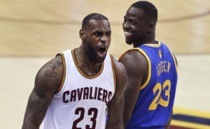

But why suspend Green? What's to gain from it besides extending the series? And while I know that the NBA loves seven-game series, I'd be surprised if that had any influence on the league's decision to suspend Green. He's fun to watch in too many ways for the NBA to *want*to suspend him. But come on, its the Finals. Why exclude one of the league's most exciting players from that for a love tap? Plus, the Green-James altercation was the best part of game 4.

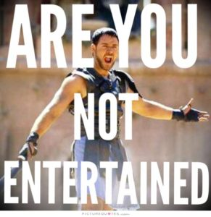

**Trash-Talking 101**

That is how you shit-talk, right there. From both sides. That's how you instigate and respond to trash-talking. Instigating didn't work out for Commodus, but that's because Maximus was the Michael Jordan of barbaric Coliseum amusement. It should be significantly easier for Draymond to get into the shockingly insecure mind of James. The guy can't handle hearing the b-word? Have a field day Draymond. LeBron will have to go full-Maximus if he wants to beat Draymond at his own game. I mean that in terms of mentality and performance. Because if James doesn't tap into his inner Gladiator, he's going to end his season playing the role of Commodus.

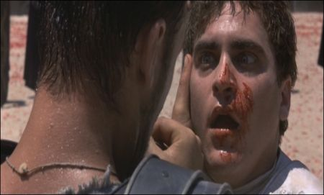

(Is Joaquin Phoenix's acting in Gladiator really good or really bad? I honestly cannot tell and I've seen the movie like six times.)

I couldn't help but wonder why LeBron cared so much about being called a bitch on the court. I've been called that countless times playing basketball, going as far back as middle school. During my senior season of high school I was guarded briefly by a power forward/linebacker/future steroid user who told me he was going to, "f*****g eat me." Isn't LeBron 31? Why can't he handle that stuff? (To his credit, he did more or less "handle it" with his 41-point, 16-rebound exhibition in game 5.)

The trash-talk hoopla continued long after the final buzzer of game 5 sounded. Shade was thrown every which way during the postgame press conferences. [Klay said LeBron's feeling got hurt](https://www.youtube.com/watch?v=1q1q1osVQTQ). LeBron "[took the high road.](https://www.youtube.com/watch?v=NQNXw1gKt-o)" How's the view from all the way up there LeBron? [Even Richard Jefferson had something to interject](http://ftw.usatoday.com/2016/06/richard-jefferson-klay-thompson-toughness).

I won't lie, it was all quality entertainment. But it's also an embarrassment. This is what trash-talking has come too in the NBA. Basketball is the preeminent sport for trash-talkers. It happens plenty in other sports, but helmets, distance from gameplay and other factors make it difficult to see, let alone hear. Trash-talking is a part of the game but the NBA has become too soft. The competition level is just as high as it's ever been, but it doesn't appear that way when guys get all wound up over a couple cuss words.

A man's game.

I found myself thinking about the all-time great trash-talkers (some of whom would surprise you) and how LeBron would've reacted to the things they had to say. I wondered, what would be the starting five of LeBron's nightmares; the perfect team to get into the head of any player? Let's take a look at ultimate starting lineup of trash-talking legends and the stories that made them hall-of-fame yappers.

**The All-Talk Team**

**Point Guard - Gary Payton**

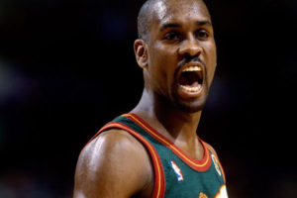

Payton was likely the most talkative of anyone on this team. Every player has their own trash-talking strategy. Payton's? Never shutting up. I'm sure players blocked the words out easily after a certain point, but that constant chatter—on both ends of the floor—must've driven players crazy.

His most infamous trash-talking moments include the time he frustrated Voshon Leonard into committing three very quick fouls; the time he told the Portland Trail Blazers, "I can do anything I want out here boy, anything."

There's also that time GP called Timberwolves coach, Sydney Lowe a smurf and ordered him to sit down.

Other players and coaches have shared their favorite Payton stories over the years. George Karl recalls the time Gary Payton and Ricky Pierce got into it on the court:

“Three years ago I didn’t see the first outbreak, but he and Ricky Pierce got into some kind of a discussion at halftime of the first Denver game, and they were threatening to get guns. The players told me they had guns in their bags. It was, ‘I’ll kill your family.’ It was crazy.”

Damn. Seems a bit over-the-line to me, but that was basketball in those days. LeBron took offense to being called a 'bitch,' apparently because he is a husband and a father. (Not sure I see the connection there Bron Bron.) Imagine how he would've reacted if Draymond told him he would get a gun from his bag and kill his family?

**Small Forward - Larry Bird**

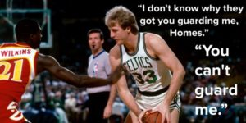

Duh.

I didn't even take a minute to review the other options. It would've been a waste of time. Bird might be the most revered trash-talker to ever grace a basketball court for two reasons. Firstly, he picked his moments and his words carefully. He wasn't yammering non-stop all game to annoy and frustrate his opponent. He preferred to bide his time and wait for a good opportunity. He would tell the defense what he was going to do to them. Then he would go out and do it.

His list of great moments is so long I have to list them. In no particular order.

* The time he walked onto the court prior to the three-point contest, looked around and exclaimed, "I hope all you guys in here are thinking about second place, because I'm winning this."
* The time he told Xavier McDaniels where he was going to hit the game-winning shot from. Guess how that ended?
* The time he asked the opposing coach if he had anyone on his roster who could guard him and the coach looked down his bench, then back at Bird and just said, "No."
* The countless times he would shout "I'm open," when defenders were on him like glue.
* The time he dropped 42 point on Dr. J, the whole time telling Doc how many points he had, as well as reminding Erving how few he had.
* If you want to read more Bird stories, [click here](http://www.viralhoops.com/larry-bird-trash-talk/).

**Power Forward - Kevin Garnett**

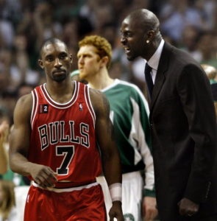

I don't think there is any rhyme or reason to Garnett's trash-talking. He says whatever comes to him in the moment. [He even made his own teammate, Glen Davis cry on the bench](https://www.youtube.com/watch?v=-rvYG8-yZIU). It doesn't seem like his trash-talking had much strategic purpose, I think he did it for himself more than anything—to get himself jacked up. He was his own energy drink.

Garnett was an expert at getting under a guy's skin. He had Joakim Noah fuming after he asked him if he could run his fingers through his hair. According to Paul Pierce, during a game, when Noah was a rookie, Noah told Garnett he idolized him and had his poster on his wall. Garnett said, "F*** you, Noah. Damn.

Garnett has no sympathy. This is a guy who talked so much trash and got under the opponent's skin so deepy that had Andray Blatche holding back tears in the middle of a game. In a game against the New York Knicks Garnett **definitely**crossed a line with Carmelo Anthony. You probably know this as the Honey Nut Cheerios Incident. [Carmelo even waited outside the Celtics bus so he could confront Garnett about it](https://www.youtube.com/watch?v=77XpjlQTBsI).

*The Onion:*"[Wife Kept Up All Night By Kevin Garnett Talking Trash In Sleep](http://www.theonion.com/article/wife-kept-up-all-night-by-kevin-garnett-talking-tr-37611)"

**Center - Hakeem Olajuwon**

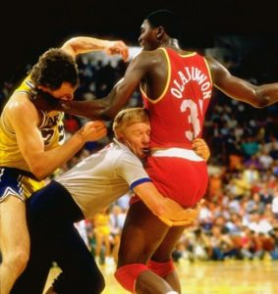

Surprised? Believe it or not, Hakeem The Dream was one of the most prolific trash-talkers on his generation. He had a unique style of trash-talking too. Shaq once recalled playing Olajuwon in the Finals. O'Neal said every time he scored Olajuwon would say something to the effect of: *Nice move, young fella. But you should've gone to [that] spot.*How enraged would you be after a while? Here you are, thinking you're doing well and this guy, totally unimpressed, is patronizing you every time down the floor. Eventually, that **has**to get to you.

Kevin Garnett listed him as one of the top three trash-talkers he faced during his career, along with Payton and Jordan. The interviewer asked if Garnett could make out what Olajuwon was saying despite his accent and his mouth guard. Garnett answered, “I definitely could hear it, articulate it, understand it, comprehend it. Yeah. Hell yeah. He was a nightmare some nights, man."

Anyone Kevin Garnett describes as a "nightmare" is probably really, really good.

**Shooting Guard - Michael Jordan**

Another duh. Jordan wasn't obnoxious like GP; he didn't get a rush from telling defenders what he was going to them like Bird, or from enraging his opponents like KG. He'd come out with a big smile and a handshake. Maybe he'd shoot the shit with you. All the while he's thinking about embarrassing you. Michael was *cold-blooded.*

MJ usually kept himself entertained by keeping a running conversation going with whoever was covering him/whoever he was covering. His initial intention was to get into his opponents head, to make them feel like they needed to prove themselves. Players became so focused on trying to impress MJ that they neglected their team's strategy.

When the stakes got higher Mr. Nice Guy disappeared. By the time the Conference Finals came around his money-making smile was gone. It was almost as if he stored it in a box somewhere until he needed it. He took any sort of slight as a declaration of war ([just ask Jeff Van Gundy](https://www.youtube.com/watch?v=ZSKH7DO5rHQ)). The man could turn anything into motivational fuel. And as gifted a trash-talker as he was, he was even better at embarrassing opposing loud-mouths. Jordan loves scorching any player dumb enough to challenge him.

My personal favorite trash-talking story happened just before the '92 Olympics. If you've seen the Dream Team documentary you know that head coach, Chuck Daly purposely threw the team's first scrimmage against a team made up of the best college players in the country. He wanted to teach the players a lesson, and it worked masterfully. The day after the discouraging loss the two teams squared off again. Allan Houston had a big first game and made the mistake of bragging about it. At tip-off during the second game, Michael pointed at Houston, said, "I got him." Rumor has it the future-NBA semi-star didn't touch the ball once the entire scrimmage.

There is the time he called Mugsy Bogues a midget and told him to shoot the ball. Mugsy obliged and missed. He claims that that moment was the beginning of his decline.

Against the Nuggets he dedicated his free throws to Dikembe Mutombo and made them with his eyes closed...just for fun.

It wasn't just the NBA players who faced Michael's wrath. Coaches, owners, and general managers were never off limits for MJ. In Utah MJ put a dunk down on John Stockton. Jazz owner, Larry Miller stood up and shouted, "Hey! pick on someone your own size." *Literally*one play later Jordan threw it down over 7'1" Jazz center, Mel Turpin. He proceeded to stare down Larry Miller and ask, " Was *he*big enough?"

I could keep going for days, [but I'll let you do that yourselves](http://www.viralhoops.com/michael-jordan-trash-talking-stories/).

Trash talking is a part of basketball. It's a part of every sport. It's a part of video games, board games, wiffle ball...you name it. While the current state of on-court banter is mostly a joke, we as fans can still hope. Hope that superstars develop thicker skin; hope that the NBA will move away from all the technical and flagrant foul calls (doubtful); hope that guys like Draymond Green will carry forward the traditions of his foul-mouthed forefathers.

Honorable Mentions go out to: Reggie Miller, Paul Pierce, Kobe, Sheed, Mark Cuban, and Charles Barkley.